**ARYAMAN MISHRA**

**19BCE1027**

**Write an 8086 ASM code to perform the following operations**

**a) ADD a 3 x 3 matrix**

ASSUME CS:CODE

CODE SEGMENT

START: MOV SI,5000H

MOV DI,6000H

MOV CL,09H

MOV BX,7000H

L1:MOV AL,[SI]

ADD AL,[DI] ;;SUB FOR SUBTRACTION

MOV [BX],AL

INC SI

INC DI

INC BX

DEC CL

JNZ L1

INT 3

CODE ENDS

END START

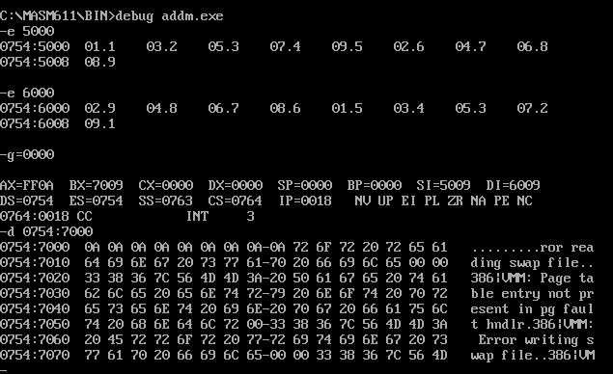

**b) subtract a 3 x 3 matrix**

ASSUME CS:CODE

CODE SEGMENT

START: MOV SI,5000H

MOV DI,6000H

MOV CL,09H ;;CHANGE TO 4 FOR 2X2

MOV BX,7000H

L1:MOV AL,[SI]

SUB AL,[DI] ;;SUB FOR SUBTRACTION

MOV [BX],AL

INC SI

INC DI

INC BX

DEC CL

JNZ L1

INT 3

CODE ENDS

END START

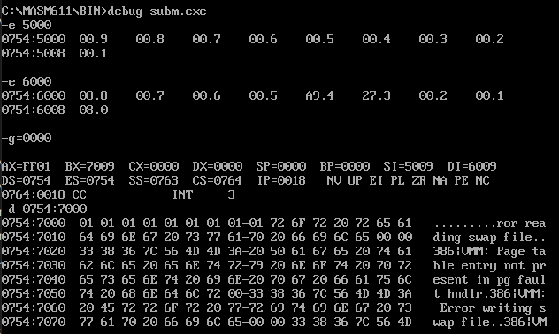

**c ) perform the operation Y= 2A where A is 3 x 3 matrix**

ASSUME CS:CODE

CODE SEGMENT

START: MOV SI,5000H

MOV DI,5000H

MOV CL,09H

MOV BX,7000H

L1:MOV AL,[SI]

ADD AL,[DI]

MOV [BX],AL

INC SI

INC DI

INC BX

DEC CL

JNZ L1

INT 3

CODE ENDS

END START

